
PROJECT REPORT
ON
Movie Recommendation System

Program Name: BCA
SUBJECT NAME: Artificial Intelligence
SUBJECT CODE:24CAT-296

SUBMITED BY:

Name : Harmanpreet,Nidhi UID : 24BCD10073,24BCD10103
Branch : BCA(DS) Section: 24BCD1(B)
Semester : 4TH

SUBMITED TO:

Name : Mr. Dheeraj

Desigination: Assistant Professor
sign: ____________________

ACKNOWLEDGEMENT

We would like to convey our heartfelt gratitude to Mr. Dheeraj sir for his continuous support and help for the completion of this project. We are grateful to Dr. Arun Kumar Gupta, Head of the Department for giving us such a great opportunity to work on this project. We are thankful for their encouragement and cooperation throughout this project. We would like to thank our Parents and Friends for their immense support. We work hard on this project and would like to take this time to thank each and every one of them who supported us directly or indirectly. It was indeed a great learning experience.
Artificial Intelligence
Movie Recommendation System
1. Aim
The aim of this project is to design and develop a Movie Recommendation System that can intelligently suggest movies to users according to their interests, previous ratings, and viewing preferences. The system uses Collaborative Filtering, an Artificial Intelligence technique that analyzes the behavior of users with similar tastes and recommends movies they may enjoy.
The project also aims to reduce the time users spend searching for movies by providing personalized suggestions. It helps improve user experience on streaming platforms such as Netflix, Amazon Prime, and Disney+ by making content discovery faster, easier, and more accurate.
In addition, this project demonstrates the practical application of AI, data analysis, and machine learning concepts in real-world entertainment systems.

2. Performing Task :
Introduction:
With the rapid growth of online streaming platforms such as Netflix, Amazon Prime, and Disney+, users are presented with thousands of movie choices. Finding relevant movies according to personal taste can be difficult and time-consuming. A Movie Recommendation System solves this problem by analyzing user preferences and recommending movies that match their interests.
This project uses Collaborative Filtering, one of the most popular recommendation techniques. It works by identifying similarities between users or movies based on ratings and preferences. If two users have similar interests, movies liked by one user can be recommended to the other.
Recommendation systems are widely used in entertainment, e-commerce, music platforms, and social media applications.
Objectives:
• To build an intelligent system that recommends movies to users.
• To analyze user ratings and preferences.
• To implement collaborative filtering for personalized recommendations.
• To improve user experience by reducing search time.
• To understand the practical use of AI in entertainment platforms.
Tools and Technologies Used:
• Python
• Pandas
• NumPy
• Scikit-learn
• Collaborative Filtering
• Jupyter Notebook / VS Code

3. STEPS INCLUDE :
S1) Data Collection
Collect a movie dataset containing movie titles, user IDs, and ratings.
S2) Data Preprocessing
Clean the dataset, remove missing values, and arrange data into user-movie rating matrix.
S3) Recommendation Generation
Use collaborative filtering to find similar users or movies and recommend unseen movies.

4. Algorithm / Logic / Flow Chart
Algorithm:
- Start the program.
- Load movie ratings dataset.
- Clean and preprocess data.
- Create user-movie matrix.
- Calculate similarity between users/movies.
- Identify nearest matches.
- Recommend top-rated unseen movies.
- Display recommendations.
- Stop.
Logic:
- If users have similar ratings, they may like similar movies.
- Recommend movies liked by similar users but not yet watched by the target user.
Flow Chart:
Start
↓
Load Dataset
↓
Clean Data
↓
Create User-Movie Matrix
↓
Calculate Similarity
↓
Find Similar Users
↓
Generate Recommendations
↓
Display Suggested Movies
↓
Stop

5. Code Overview
• Pandas is used to load and manage movie datasets.
• NumPy helps in matrix operations.
• Scikit-learn is used for similarity calculations.
• Collaborative Filtering compares user preferences.
• The final output displays recommended movies for the selected user.
Main modules:
- Dataset loading
- User-item matrix creation
- Similarity score calculation
- Recommendation engine
- Result display
6. Code
# ==========================================
# MOVIE RECOMMENDATION SYSTEM
# NICE GUI VERSION USING TKINTER
# ==========================================

import tkinter as tk
from tkinter import messagebox

# ------------------------------------------
# SAMPLE DATASET
# ------------------------------------------
ratings = {
"User1": ["Inception", "Titanic", "Avatar", "Interstellar"],
"User2": ["Inception", "Titanic", "Avatar", "Avengers"],
"User3": ["Interstellar", "Avatar", "Titanic", "Avengers"],
"User4": ["Inception", "Interstellar", "Avatar", "Joker"]
}

# ------------------------------------------
# RECOMMEND FUNCTION
# ------------------------------------------
import tkinter as tk
from tkinter import messagebox

# ------------------------------------------
# SAMPLE DATASET
# ------------------------------------------
ratings = {
"AMAN": ["KGF", "TITANIC", "QISMAT", "PK"],
"NIDHI": ["BAMBUKAT", "SAIYAARA", "AVATAR", "ISHQAAN DE LEKHE"],
"REHMAT": ["YJHD", "KKKG", "RAMAYAN", "CARRY ON JATTA"],
"HARMAN": ["ARDAAS", "QISMAT", "BRAHMASTRA", "Joker"]
}

# ------------------------------------------
# RECOMMEND FUNCTION
# ------------------------------------------
def recommend():
user = entry.get().strip()

if user not in ratings:
messagebox.showerror("Error", "User not found!")
return

watched = ratings[user]
suggestions = []

for other_user in ratings:
if other_user != user:
for movie in ratings[other_user]:
if movie not in watched and movie not in suggestions:
suggestions.append(movie)

result_box.delete(0, tk.END)

if len(suggestions) == 0:
result_box.insert(tk.END, "No Recommendations")
else:
for movie in suggestions:
result_box.insert(tk.END, movie)

# ------------------------------------------
# GUI WINDOW
# ------------------------------------------
root = tk.Tk()
root.title("Movie Recommendation System")
root.geometry("500x500")
root.config(bg="#1e1e2f")

# Title
title = tk.Label(
root,
text="🎬 Movie Recommendation System",
font=("Arial", 18, "bold"),
bg="#1e1e2f",
fg="white"
)
title.pack(pady=20)

# User Input
label = tk.Label(
root,
text="Enter User Name:",
font=("Arial", 12),
bg="#1e1e2f",
fg="white"
)
label.pack()

entry = tk.Entry(root, font=("Arial", 12), width=25)
entry.pack(pady=10)

# Button
btn = tk.Button(
root,
text="Get Recommendations",
font=("Arial", 12, "bold"),
bg="#4CAF50",
fg="white",
command=recommend
)
btn.pack(pady=10)

# Result Box
result_box = tk.Listbox(
root,
width=40,
height=12,
font=("Arial", 12)
)
result_box.pack(pady=20)

# Footer
footer = tk.Label(
root,
text="Available Users: AMAN,NIDHI,REHMAT,HARMAN",
font=("Arial", 10),
bg="#1e1e2f",
fg="lightgray"
)
footer.pack(side="bottom", pady=10)

root.mainloop()

7. OUTPUT : (SCREENSHOT)
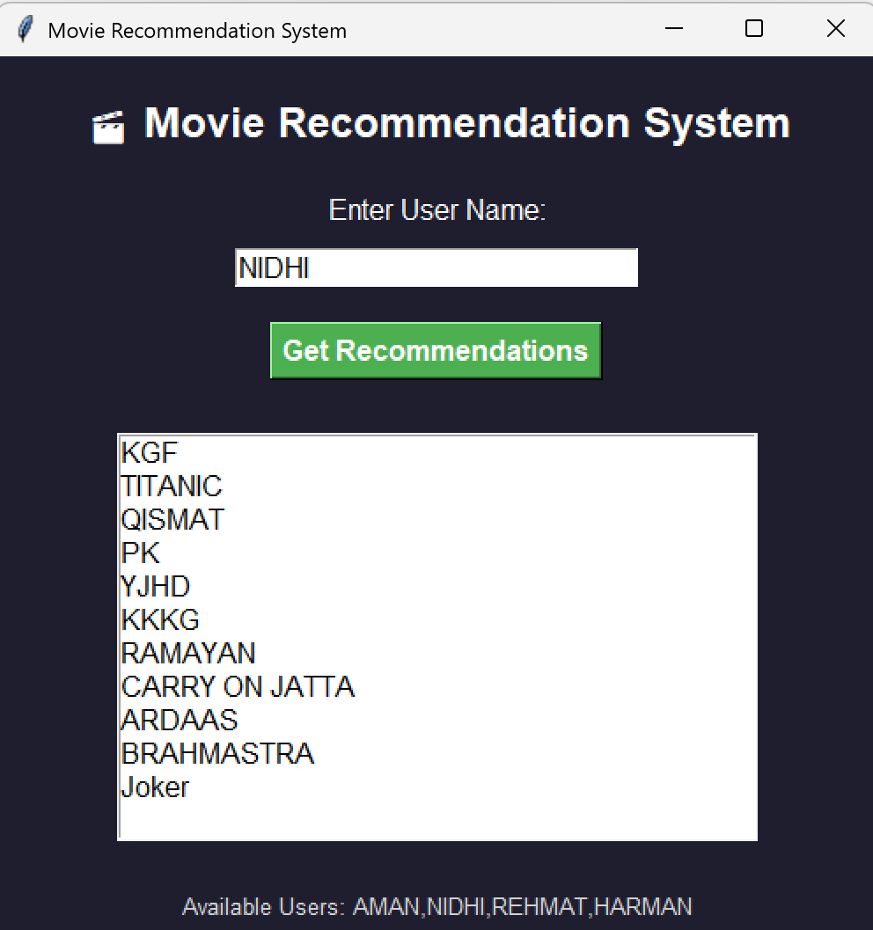

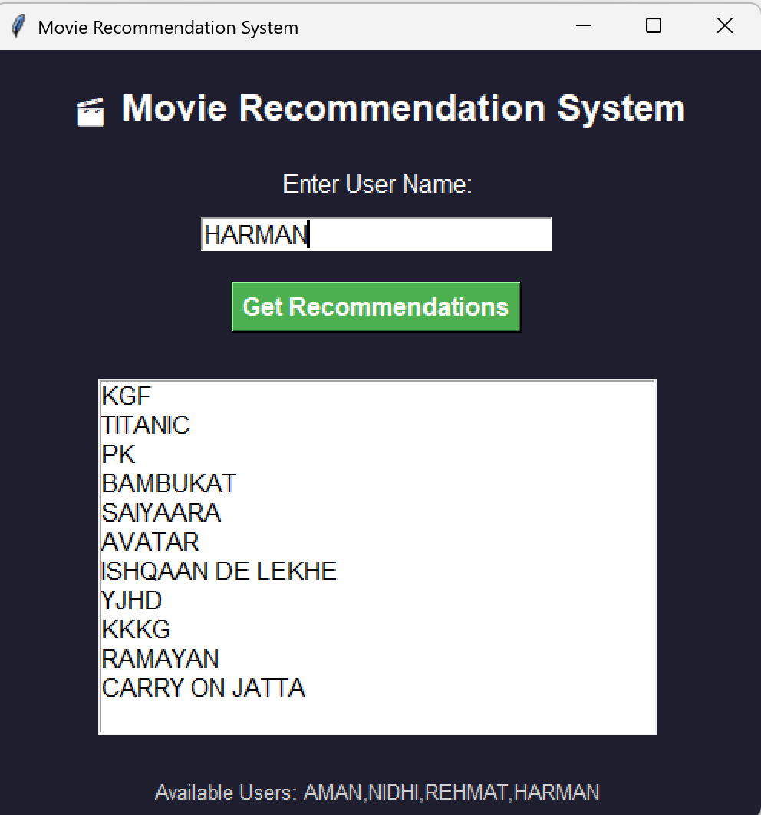
8. Conclusion
The Movie Recommendation System is an effective application of Artificial Intelligence that helps users find movies based on their interests and preferences. By using Collaborative Filtering, the system analyzes user choices and recommends movies liked by similar users. This saves time and makes movie selection easier and more personalized.
The project shows how AI improves user experience on platforms like Netflix and Amazon Prime by providing smart suggestions. It also helps in understanding important concepts such as Python programming, recommendation algorithms, data handling, and GUI development.
Overall, this project is practical, useful, and relevant in today’s digital world. It demonstrates how AI can make entertainment systems smarter, faster, and more user-friendly.

9. LEARNING OUTCOMES:
- Learned the concept of recommendation systems.
- Understood collaborative filtering techniques.
- Learned user similarity and movie similarity methods.
- Improved Python programming and data handling skills.
- Understood how AI personalizes user experiences.
- Learned practical applications of AI in OTT platforms.
- Developed knowledge of real-world intelligent systems.
10. Screenshots (GITHUB UPLOAD)

